**Swinburne University of Technology**

Ho Chi Minh Campus

**Extension on mobile UX patterns**

**COS30017 – Software Development for Mobile Devices**

Tran Thanh Minh - 103809048

March 2024

# Pattern 1: Bottom navigation bar

2 icons for navigating between Mail and Meet

Image 1: Gmail application

The bottom navigation bar is persisten UI element positioned at the bottom of the screen. It house 2 icons representing core functionalities of the app. It provide quick access to Mail or Meet, it promotes easy navigation as it’s readily accessible with thumb on most phones. The active icon will have the color while the inactive icon will have the transaparent color to make the contrast so that the user can know which one is active (Material Design, 2024).

However, it doesn’t display the name of the icon to navigate to so with people who have low computer literacy, it is hard to use.

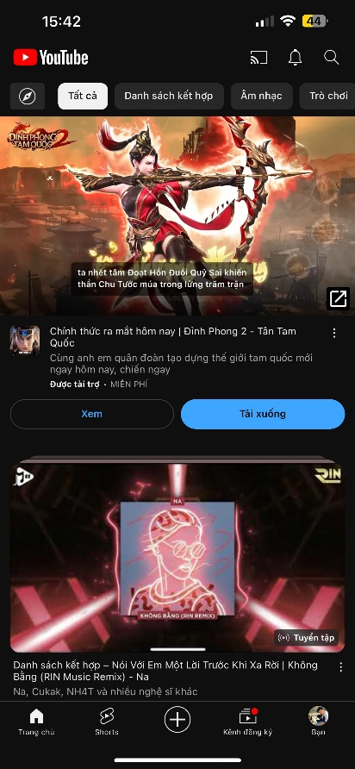

Description of each icon for users easy to know where to navigate

Active icon, high contrast

Image 2: YouTube application

The Gmail app typically has 2 icons, whereas YouTube's bar in the image has 4 - 5 icons. Having more than 4 icons can make the bar cluttered and harder to use. The description mentions the Gmail icons provide access to Mail and Meet, while YouTube's icons navigate users to various browsing and content management sections of the app.

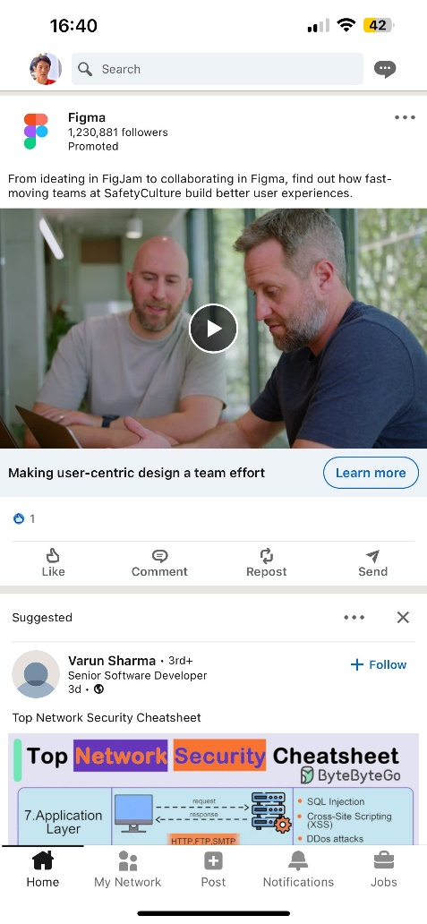

Image 3: Linkedin

Home icon brings users to the LinkedIn feed, where they can see updates from their network. Search allows users to search for people, jobs, companies, and groups on LinkedIn. Network icon might lead to a section showcasing a user's connections and network. Notifications icon likely allows users to see their LinkedIn notifications. The bottom navigation bar provides users with quick access to core features of the app. Like the YouTube app's tab bar, it's positioned for easy reachability with a thumb at the bottom of the screen.

A bottom navigation bar is a common pattern for mobile apps, offering easy navigation and clear visual cues. However, including too many icons can clutter the bar and reduce usability. Without knowing the exact number of icons in LinkedIn's bar, it's difficult to say definitively if this is the case.

# Pattern 2: Notifications

Doesn’t notify new email.

Only display when click side bar

Number of new emails

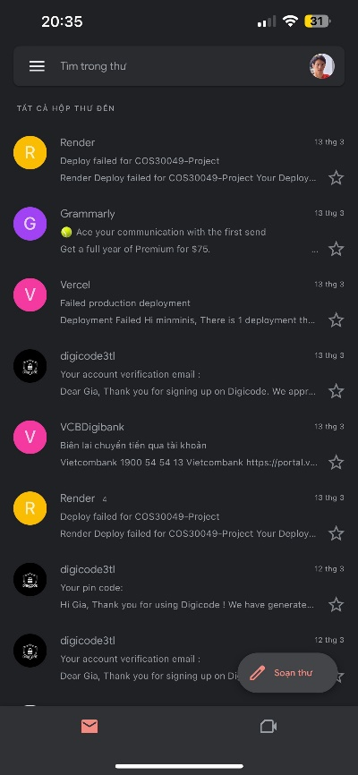

Image 4 & 5: Notifications of Gmail

Here is the notification of the Gmail. It doesn’t display the number of new notifications on the navbar. It only displays on the side bar, depending on the users, most of them may not know about they have received any new email. However, it is good when displaying the number of new emails when opening the side bar.

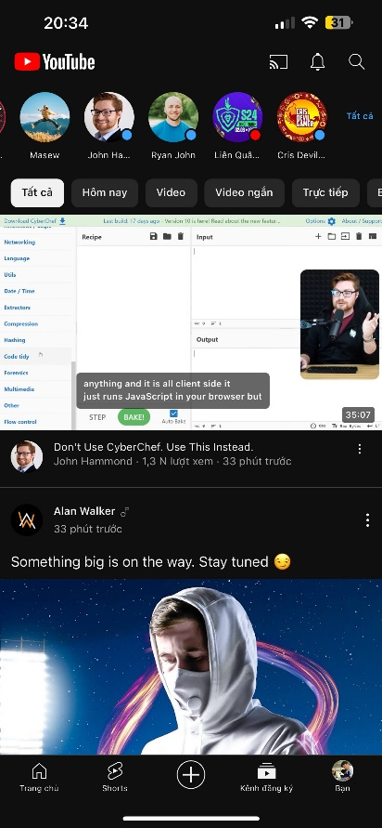

Doesn’t notify any.

Just display red dot

Image 6 & 7: Notification of YouTube

Notification of YouTube doesn’t notify how many new videos which are published. Sometimes it just displays a small red dot so it doesn’t provide any summary or any detail much which can be considered as a bad design (Anders Toxboe and Anders Toxboe, 2024).

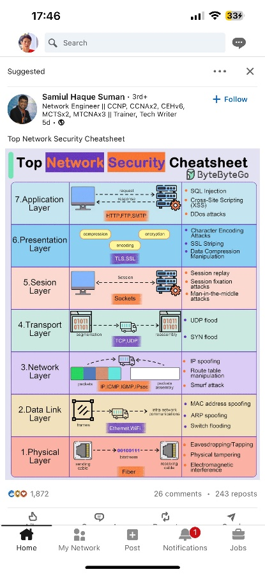

Unread notifications is coloured

Display number of new notifications

Image 8 & 9: Notification for LinkedIn

Here is the notification of LinkedIn, it displays well for those unread notifications and notifies the user the number of new notifications. This is good practice of how to notify the user.

# Pattern 3: Liking

Number of views

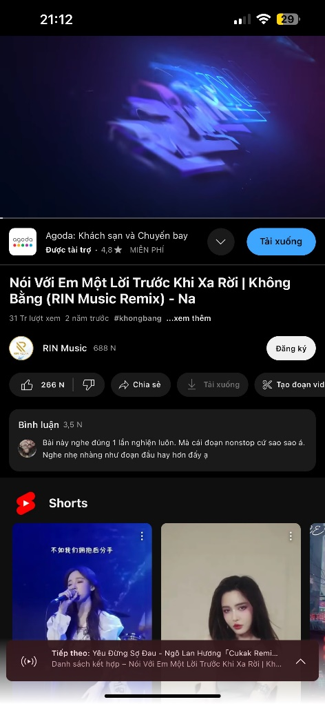

Comments

Number of likes

Image 10: Liking of YouTube

It displayed the details of each video which include information such as number of likes, comments, and views.

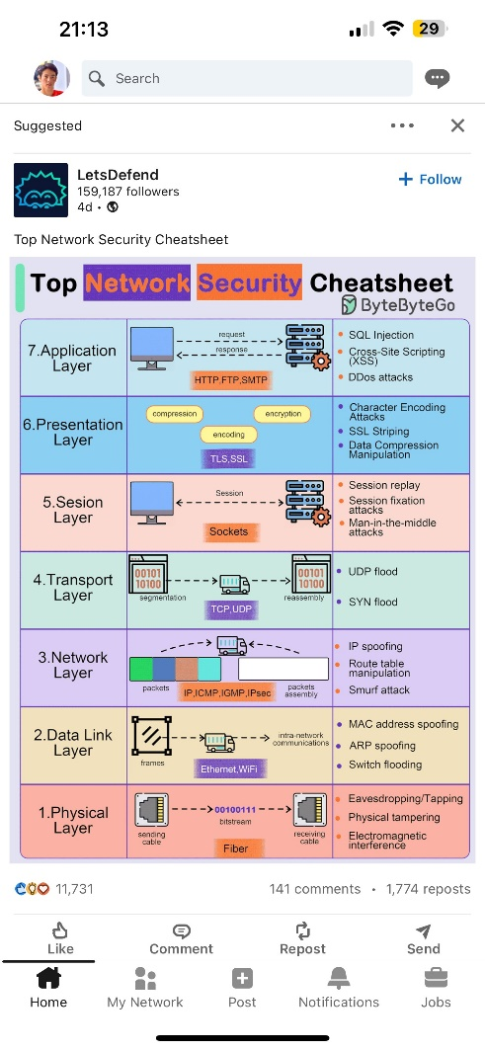

Image :11 Liking of LinkedIn

This is a good practice of displaying a number of likes, comments and reposts which is easily viewed by users.

# References

Material Design. (2024). *Material Design*. [online] Available at: [https://m2.material.io/components/bottom-navigation](https://m2.material.io/components/bottom-navigation%20) .

‌Anders Toxboe and Anders Toxboe (2024). *Notifications design pattern*. [online] Ui-patterns.com. Available at: <https://ui-patterns.com/patterns/notifications>

‌Anders Toxboe and Anders Toxboe (2024). *Liking design pattern*. [online] Ui-patterns.com. Available at: https://ui-patterns.com/patterns/Liking

‌